Smoke in Your Eyes: A Teaching Resource Exploring Tobacco Issues

Below is a selection of possible lesson ideas for Nursery/Primary 1 for any nursery/primary schools that may wish to introduce the theme of Tobacco. All suggestions are linked to the Health Experiences and Outcomes for Early Level.

Stage: Early Years Theme: Tobacco

Health and Wellbeing Experiences & Outcomes:  Social Wellbeing:  - As I explore the rights to which I and others are entitled, I am able to exercise these rights appropriately and accept the responsibilities that go with them. I show respect for the rights of others. HWB 0-09a  Substance Misuse:  - I understand there are things I should not touch or eat and how to keep myself safe, and I am learning what is meant by medicines and harmful substances. HWB 0-38a  - I can show ways of getting help in unsafe situations and emergencies. HWB 0-42a  Physical Wellbeing:  - I am developing my understanding of the human body and can use this knowledge to maintain and improve my well-being and health. HWB 0-15a  - I am learning to assess and manage risk, to protect myself and others, and to reduce the potential for harm where possible. HWB 0-16a  - I know and can demonstrate how to keep myself and others safe and how to respond in a range of emergency situations. HWB 0-17a  Planning for Choices and Changes:  - In everyday activity and play, I explore and make choices to develop my learning and interests. I am encouraged to use and share my experiences. HWB 0-19a  Physical Activity and Sport:  - I am enjoying daily opportunities to participate in different kinds of energetic play, both outdoors and indoors. HWB 0-25a  Relationships, Sexual Health & Parenthood:  - I am learning what I can do to look after my body and who can help me. HWB 0-48a | Cross Curricular Experiences & Outcomes:  Language:  - I listen or watch for useful or interesting information and I use this to make choices or learn new things. LIT 0-04a  - To help me understand stories and other texts, I ask questions and link what I am learning with what I already know. LIT 0-07a  - ‘Read’ stories where smoking/second hand smoking is the main theme (e.g. in Primary 1 the NHS Lanarkshire – Jenny and the Bear Resource) LIT 0-14a  - Audio & Video versions of Jenny & The Bear storyline can be downloaded in different formats including BSL and subtitles on www.healthyandsmokefree.scot LIT 0-14a  - Use rhythm and rhyme to introduce Jenny & The Bear puppet characters where smoking/second hand smoking is the main theme (e.g. NHS Lanarkshire – Jenny & The Bear E/Y Parent-link resource) LIT 0-14a  - Drama:  - Inspired by a range of stimuli, I can express and communicate my ideas, thoughts and feelings through drama. EXA 0-13a  - I use drama to explore real and imaginary situations, helping me to understand my world. EXA 0-14a
Suggested Learning Intention:  - To recognise that safe/unsafe behaviour can be harmful to their health and well-being  - To explore their rights and responsibilities or looking after their body  - To develop their basic understanding of the human body and apply this knowledge to maintain their health  Suggested Learning Statement:  - Understand being around smoke and noticing the effects. | Suggested Resources:  - “Jenny and the Bear” – NHS Lanarkshire Resource (a copy of the presenter and a Bear have been distributed to all primary schools across North and South Lanarkshire)  - E/Y Parent-link Resource– NHS Lanarkshire (1 set of puppet characters, selection of laminated nursery rhymes, knitting patterns and NHS SHS leaflets are available to borrow free from the Health Promotion Library.  - Additional resources to support Jenny & The Bear and Parent-link resource can be downloaded on www.healthyandsmokefree.scot  - A Bear Costume (adult size) and pop up display (Jenny and the Bear) resources relating to second hand smoke are available to borrow for free from the Health Improvement Senior for Early Years and Tobacco, NHS Lanarkshire, 14 Beckford Street, Hamilton, ML3 0TA, Tel: 01698 201456 or email Lynn.Adams2@lanarkshire.scot.nhs.uk  - Tobacco related resources are available to borrow for free for a one month period from the Health Improvement Resource Library, Law House, Airdrie Road, Carluke, ML8 5EP, Tel: 01698 377600 or visit the website: www.healthylanarkshire.org

Suggested Success Criteria (I can ….)  Children should be able to:  - Describe in simple terms the effects of smoking/second hand smoke on their bodies and breathing  - Talk about what it means to be ‘healthy’  - Identify the difference between healthy teeth and the teeth of smokers  - Discuss how smoking/second hand smoke can affect the insides of our bodies, including our lungs, making us cough and feel unwell  - Identify people, places and things and say what makes them safe, risky or unsafe  - Give examples of ways in which they can help keep themselves and others safe at home and nursery | Significant Aspect of Learning:  Learners understand the use and misuse of various substances. They understand the impact of risk taking behaviour on their life choices. They make informed personal choices which promote a healthy lifestyle.  Health &Wellbeing Indicators:  Safe  Healthy  Active  Respected  Responsible
Smoke in Your Eyes: A Teaching Resource Exploring Tobacco Issues

Stage: Early Years Theme: Tobacco

Activity | Teaching and Learning | Teaching Points/Resources
What is a cigarette? | - Show the children a picture of a person smoking (you could use the image of Jenny’s mum smoking with the bear from the Presenter or from Appendix 1) | - Many, but not all children will have experienced a time when they have been around or seen someone smoking either in their life or on television.
What is smoking? | - If discussion allows ask the children what they thought about the smell, did it make them cough, how they felt when the air was all smoky?  - In the Jenny and the Bear Resource book the bear says that “he didn’t like the smell from the lit cigarette. It made his throat feel dry and scratch” – excerpt from the Jenny and the Bear Book – Linda Morris, reproduced courtesy of NHS Greater Glasgow and Clyde. | - Ask children if they know any changers that can come from smoking (health, safety)  - Teacher Information – second hand smoke can linger in the air for up to 5 hours after a cigarette has been extinguished so the particles are still being breathed in long after the cigarette is finished.  - You can access this website for more information and a DVD Clip or on how cigarette smoke travels in a room/house: www.righoutside.org
Smokers around us and our families | - Show the children a picture of a person smoking (you could use the image of Jenny’s mum smoking with the bear from the Presenter or from Appendix 1)  - Ask the children to think about how they have felt when they were standing near this person? What did they think of the smell? Did they make them cough? How did they feel when the air was all smoky?  - Relate this back to the storyline using the bear’s feelings about smoking to discuss further. | - Many, but not all children will have experienced a time when they have been around or seen someone smoking either in their life or on television.  - It is important to let the children talk about their own experiences and not to ask leading questions though they may need some guidance when describing the looks and smell of people smoking.
Smoking and Breathing | - Talk to the children about breathing and how what we breathe in travels into our lungs.  - Inflate a pink balloon to signify how a healthy, clean lung would look. Then deflate the lung slightly to signify an unhealthy lung. | - Changes happen within our bodies when we inhale smoke and this can make us cough and hurt our lungs.
Smoking and our Teeth | - Provide the children with a picture of an open mouth smile and ask them to alter it to show what the effects can be on a person who smoke’s teeth. | - Cross curricular opportunity. It is important that children understand that the smoke from the cigarette is changing the colours of the teeth and that even through people brush their teeth the stains will stay there.
Smoking and Exercise | - Explain to the children how breathing is an important part of physical activity and explain how when they breathe fresh air it travels into their lungs and makes them expand and makes activity easier.  - Ask the children to put their hands on their chest and take deep breaths to demonstrate this.  - Ask the children what could affect their breathing when they take part in activity (e.g. cigarette smoke, smoke filled room).  - Explain that if you inhale smoke it can be more difficult to breathe and make it harder to run around and have fun.  Information in the Smoking and Exercise section is courtesy of “NLC, Active Families Health and Well-being Programme session on Second Hand Smoke”. | - Taking part in activity will give them healthy lungs.  - What can affect your breathing when taking part in sport (e.g. smoke)  - Inhaling smoke can affect their breathing which can make it difficult to participate in sport
Smoking and Fires at Home (Safety) | - Make a list with the children of different ways in which fires can start in our homes and who we would call if there was ever a fire.  - Show the children a picture of a fire hazardous home and ask them to think about the danger zones.  - Ask the children to think about how a cigarette may cause a fire in the home. | - It is important to discuss who to call in the event of a fire which most/all children should be able to explain.  - Useful web links for this topic:  www.gosafescotland.com  - www.kiddesafetyeurope.co.uk then go to ‘Education & Advice’ then ‘Kids Education’ section.

Home Links:

Colouring in Sheets:

Appendix 2: Happy and Smoke Free – Please keep smoke outdoors pdf – bear only
Appendix 3: Happy and Smoke Free – Please keep smoke outdoors pdf – house, car and bear

What can you do as a parent/carer?

The only way to fully protect your family is to smoke outside. If this is not possible, think about different things you can do to reduce the risk of exposing your family to second hand smoke. You may be aware that as of 5th December 2016, it became illegal to smoke in a car with a passenger under the age of 18. This is a positive step in protecting children from exposure to second hand smoke. More information can be found at: www.protectyourkids.scot if you smoke and want to cut down, try using nicotine replacement therapy, especially when you are with your children.

Get in touch:

Maybe in time, you will decide to stop smoking altogether. There is lots of support available and we are happy to help. You can call the Stop Smoking Service on 0300 303 0242, text ‘advice’ to 81066 or you can visit our website: www.nhslanarkshire.org.uk . You can also access support from any Pharmacy in NHS Lanarkshire area.
Useful Websites

This is not an exhaustive list and can be added to as you find other sites of use. It is essential that staff review the site content before using with children to ensure you feel it is appropriate, relevant and current.

www.sparklebox.co.uk | Downloadable free resources for teachers covering many topics
www.stickykids.co.uk | Music & movement songs to access with the Early Years curriculum
www.instantdisplay.co.uk | Downloadable resources for teachers covering many topics
www.teachingideas.co.uk | Free lesson ideas and activity resources for teachers
www.bbc.co.uk/cbeebies | Games, songs, make and colour, story time and other interactive activities for Early Years children
www.educationscotland.gov.uk | The national body for Scotland supporting quality and improvement in learning and teaching
www.child-smile.org.uk | Information for parents, carers and professionals on promoting oral health
www.southlanarkshire.gov.uk | South Lanarkshire Council website
www.northlanarkshire.gov.uk | North Lanarkshire Council website
www.nhslanarkshire.org.uk | NHS Lanarkshire website
www.healthylanarkshire.org | NHS Lanarkshire – Health Improvement Resource Library
www.healthscotland.com | NHS Health Scotland website
www.rightoutside.org | Government website looking at second hand smoke in the home
www.gosafescotland.com | Safety advice website – contains Curriculum for Excellence level activities
www.ashscotland.org.uk | Independent Scottish charity who work to reduce harm caused by tobacco
www.kiddesafetyeurope.co.uk | Interactive site that helps children to understand the dangers that could happen around the home (Go to Education and Advice then Kids Education Box)
www.free-for-kids.com/home-safety-for-children.shtml | Free downloadable resources for children around various safety topics

Appendix 1

Jenny’s mum smoking at the window.
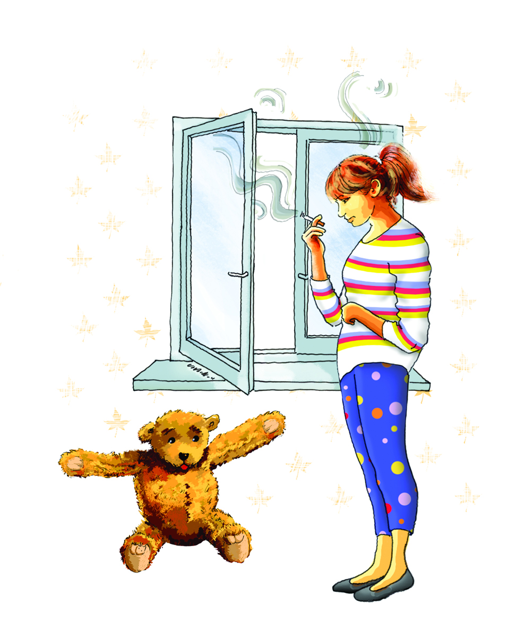

Reproduced with kind permission from NHS Greater Glasgow and Clyde

Appendix 2

Happy and Smoke Free – Please keep smoke outdoors – Bear only (Colouring In Sheet)

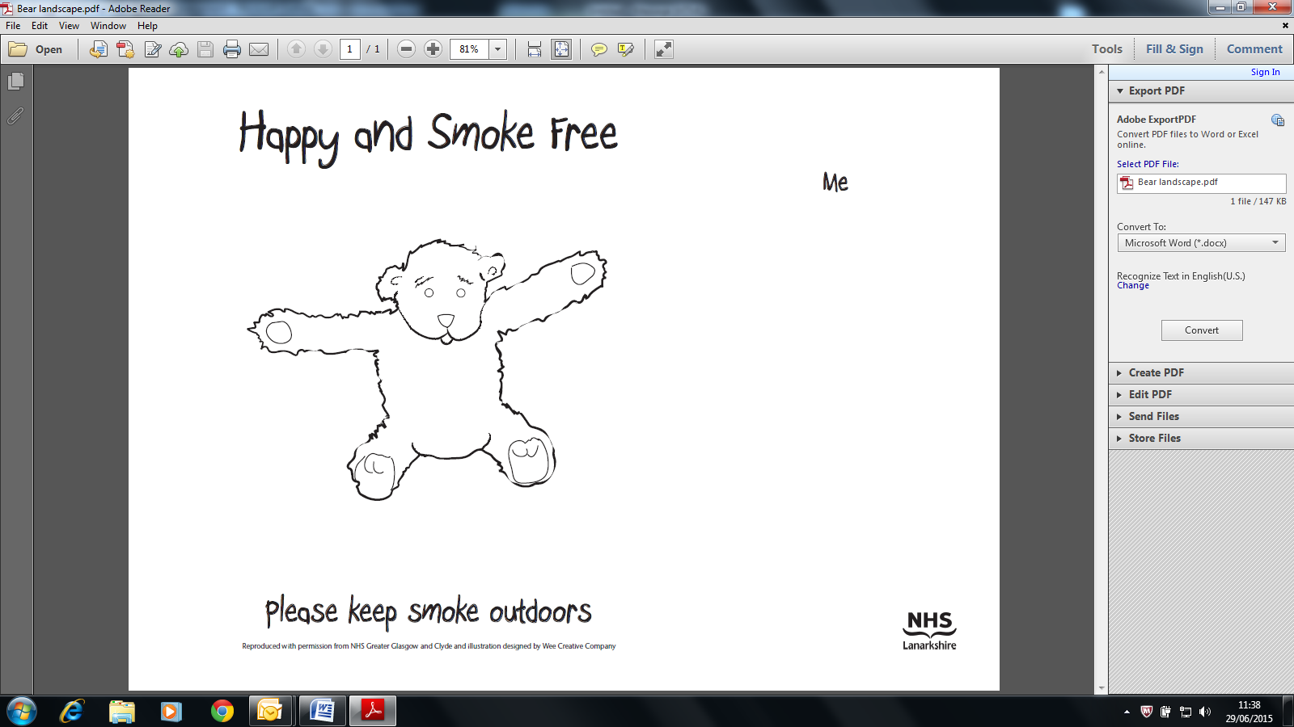

Appendix 3
Happy and Smoke Free – Please keep smoke outdoors– house, car and bear (Colouring in Sheet)
